Maniratnam Palkur

Usability Study on Microsoft One Drive

8/1/2016

Introduction: -

About Microsoft: -

Microsoft corporation is one of the American multinational technology company which develops and supports computer software, electronic supplies and personal systems and other services. They Also well known for their Operating systems (OS), Micro office suite and also internet explorer as well. They are not only popular for software products but also for their hardware products like Xbox games, Microsoft tablets and mobile phones. Microsoft was founded on April 4, 1975, by Paul Allen and Bill gates. It was developed to lead the personal computer operating system market in the mid of 1980s with their Ms-DOS product and then its reign followed by Microsoft windows. The operating systems which were developed by the Microsoft corporation are Linux, MS-DOS, and then the history of windows has started with the Windows 1.0, Windows 2.0, windows 3.x, Windows 95, windows 98, windows 2000, windows ME, windows XP, Windows Vista, Windows 7, Windows 8,8.1 and the present version in the market is Windows 10. One of the product developed by Microsoft is ‘One Drive’ in online.

About One Drive: -

One Drive is online service which allows a user to their sync files to online storage system and they can access them through their web browsers or from their mobile devices as well.

To utilize this service a user just only need to create an account in the Microsoft, if once he completed with that he can just access them through any place at any time. One Drive is normally included in the online services suite which is called as Windows Live.

One Drive provides a storage limit of 5GB for the free users at present and when it has developed it provided 15GB of data for the storage purpose and it has detected to 5GB on 31st January 2016 to the free users and it is constant for paid subscribers they can 1TB of storage limit.

At the beginning stages One Drive is named as Sky Drive and later on changed in windows Live Sky Drive and windows Live folders and finally it has changed to One Drive. This service came existence in America for the first time on 1st August 2007 and in few days gap it has launched in United Kingdom and India foe the testing purpose on August 9th 2007.A year it was made to available in 38 countries in May 2008 and later increased to 62 countries in December 2008.At the very it had an feature of adding files, photos and other contents in a combined way, but Microsoft created a separate portal to add the photos and videos also they can tag the people in the photos too, so that those photos can be downloaded in zip file. One Drive consisted with feature of recycle bin, so that if a user deletes his data it just moves the recycle bin and it doesn’t get lost until a user deletes in them as well. One after it got updated to “Wave 4” it started to allow a user to upload, edit, create and share option in any formats like Word, excel, power point and One note documents directly in the browsers only. Basically in One Drive a user can open a document in the PDF, ODF and XML based files. One Drive has an inbuilt feature of geolocation in which it can add the location of the photos were it captured and uploaded through the windows photos gallery, and they can be viewed through automatic slideshow as well. Finally, the privacy in the One Drive is monitored by Microsoft and if any data is uploaded against to the rules of the policy they can remove them and may close the user account temporarily or permanently. In addition to, that One Drive provides the security to the data which have uploaded by a user.

Study Proposal: -

In this usability study I will be studying in One Drive on the particular modulus of search operation and uploading/ downloading a text document or image file whether it is compressed or not.

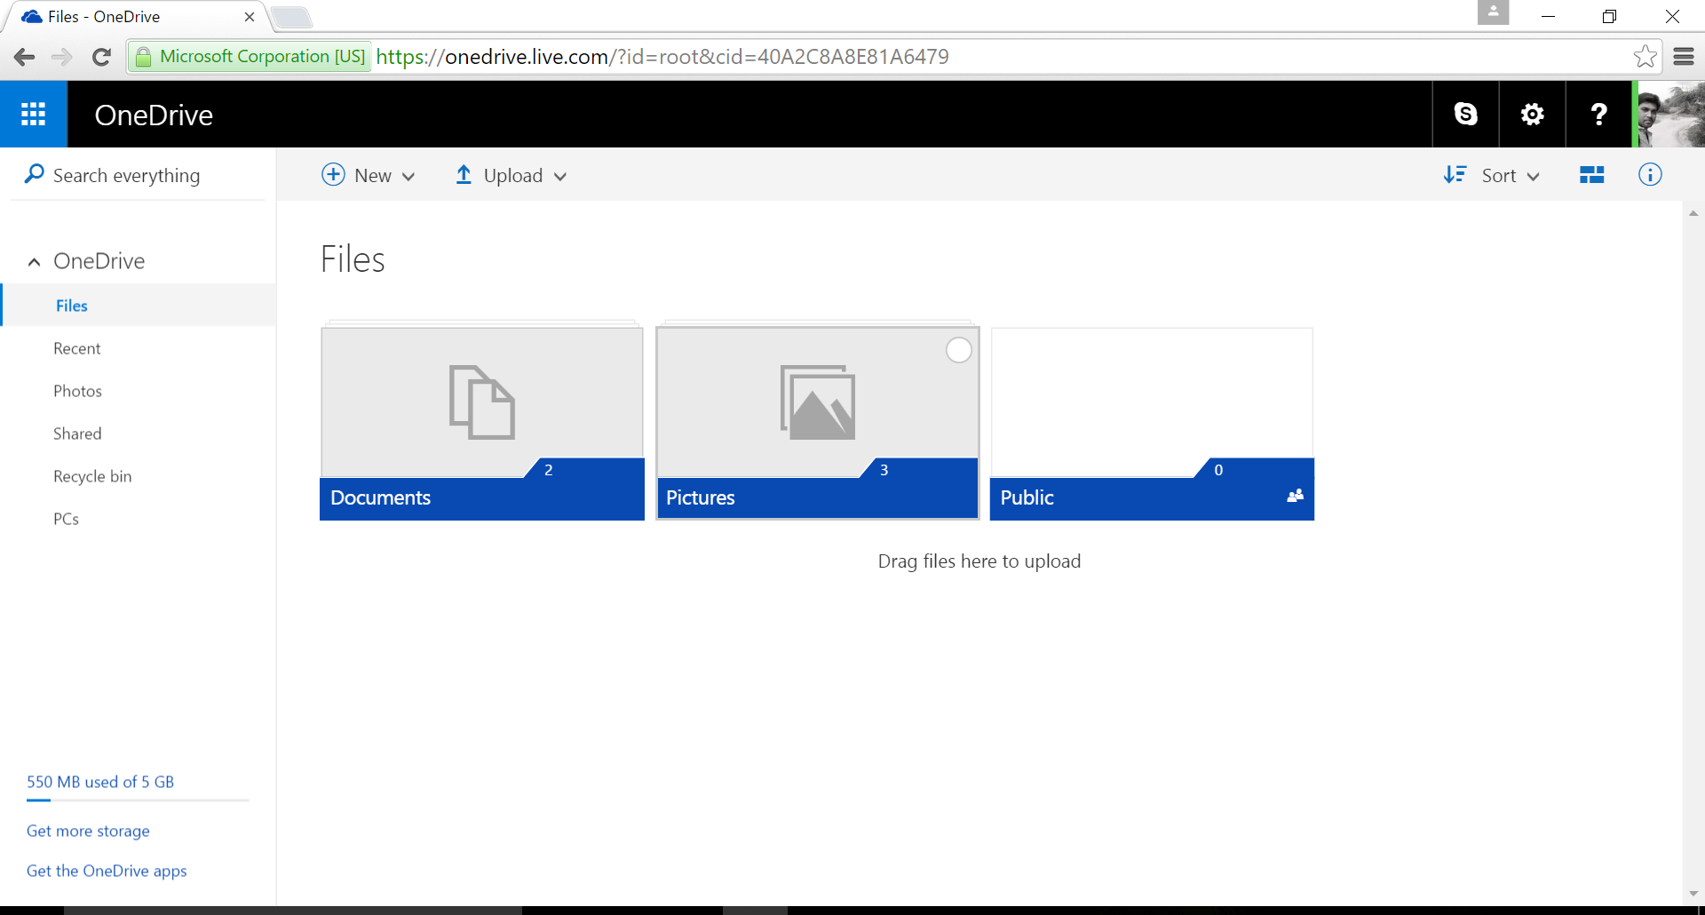

This is the main page in One Drive when a user login into that, it contains the menu like Files, Recent folders, Photos were a user can upload the pics and save it, shared folder were the shared documents have saved and the recycle bin that if a user delete’s a file it will store in the recycle bin until a user deletes in them too. Finally, PC’s folder syncs with the user personal computer so that if he contains an important in their PC they will automatically upload in them as well.

In this page you can observe the search operation doesn’t have the filter option to search a file easily without any interruption. Also a One drive provides a data storage limit of 5GB for a free user to store their personal documents.

Main objectives of the study: -

1. To observe and study the time consumption during the login process.
2. Also to observe that the participant has got any issue while logging into the One Drive account.
3. Observe and study the comparison between upload and download time if the quality of the document or an image is same or not.
4. Understand the overall usage of One drive to a user.
5. Also how a search operation in One Drive is useful for a user.

Site Visit: -

One Drive is used by a lot of users these days, so I took a survey in both online and planned for a site visit so that it would be helpful to my study.

About Participants: -

For the site visit study, I got 5 participants where they have shared their valuable information to my study. The participants who participated in this survey had their accounts in the Microsoft One drive from past 6 months and they got an idea a how does it works? And also the problems that have they faced. So, by collecting a data from them it will be helpful for me to make the more relevant the content. All the participant’s chose the location of 24/7 lab in CCIT building and this helped me and also the participants more comfortable and made the study successfully. I have started this survey in 30th July and 31st July, ahead of the survey I have intimated them about the survey and how much time does consume like 10-15 minutes, so that they adjust their time to attend this survey. I have observed and studied the participant’s opinion about One Drive and analyzed the data.

Collection of Data: -

A form is created in both online by using Google form and for the site visit I created a form which includes a few questions about the One Drive and was asked the participants to perform task and also asked to rate the overall usage of the One Drive. The form that I have created is shown below.

Name:

Date: Time:

Mail I’d:

Location of the test held: Home/ Office/ Other:

Temp: Cold/Mild/Hot:

1. How often do you use One Drive?

Beginner/ Moderate/ Expert _______________________________________________

Task 1: -

1. Do you have a One Drive account?

Yes/No____________________________________________________________________

1. If No, try to create an account in One Drive and check whether you got any issues while creating that?

Yes/No ______________________________________________________________

1. If yes, observe how much time does it take to open the account?

Time___________________________________________________________________

Task 2: -

In this try to upload a document and image file in One Drive

5) Have you got any difficulties in uploading a data/ document?

Yes/No___________________________________________________________

1. If yes explain the issue that you have got.

__________________________________________________________

7) When you upload an image to one drive and when you download the same image, did you get the same clarity (view of the image)?

Compressed/original/Not sure___________________________________________________

8)Is the search operation in One Drive is helpful to you?

Yes/no __________________________________________________________________

9) If No, can you explain what modifications need to added in it?

___________________________________________________________

10)Do you think filter option need to be included in the search operation?

Yes/no/notnecessary______________________________________________________

|  |  |  |  |  |
| --- | --- | --- | --- | --- |
| 1 | 2 | 3 | 4 | 5 |

11)Rate the search operation in One Drive in the scale on the scale 1-5

12)Rate the overall performance and Usage of One Drive on the scale 1-5

|  |  |  |  |  |
| --- | --- | --- | --- | --- |
| 1 | 2 | 3 | 4 | 5 |

13)Have you got any suggestions to make the One Drive more user-friendly?

________________________________________________________________

Thank you for your support.

This was the form that I have given to the participants in the site visit. And the filled form is attached in appendix section A in the end of this document. Also other form to the participants who participated in the survey through online is also provided to them as well. I have made the site visit approach and the form to make this survey by following the “User and task analysis for interface design” book by Joann Hackos.

Issues during site visit: -

While performing this task I got some issues with two participants with their timings mismatch to me and to the participant and a participant has got struck with his personal issues, so he made the survey with lack of concentration and made that form really quick. This visits had me a bit complicated and I took a few measure for the remaining two surveys so that no error should occur in this visits.

Analysis of site Visit: -

The data is collected from the both site visit is analyzed in two methods, **1. Vignette Scenario 2. Data matrix**. Here a vignette scenario is used to collect the data from the participants and to summarize them to show the content easily and data matrix is used to prepare the obtained content in a tabular form, these both methods are used from the book “Hackos and Radish”.

Vignette Scenario: -

This created a summary of the data which we got from the 5 participants on a site visit. They felt easy with the task I have provided them and I about the navigation from the login page to account feel comfortable. They were also little disappointed with search operation, they got a feel to add a filter option in that any user can easily search the files or videos or images easily. I have made them to upload a document and image having high quality so to check whether the image is getting downloaded as original quality or it getting compressed, maximum participants got agreed to the quality of it has got compressed and some didn’t realize that, a few of them not sure. I observed that almost all the participants in the site visit has got 6 seconds to navigate from the login page to their account.

Data Matrix: -

This is the table for the data which is collected from the site visit which includes the data collection from the 5 participants. This data is collected their answers to the questions that were asked in the form.

|  |  |  |  |  |  |
| --- | --- | --- | --- | --- | --- |
| Data matrix | | | | | |
| Observations | P1 | P2 | P3 | P4 | P5 |
| Date | 30/07/2016 | 30/07/2016 | 31/07/2016 | 31/07/2017 | 31/07/2016 |
| Time | 11:30 Am | 11:45 Am | 3:30 pm | 4:00pm | 6:30 pm |
| Location | College | College | College | College | college |
| Questions/ task |  | | | | |
| Experience of computers | Expert | Moderate | Moderate | Beginner | moderate |
| Experience on Browser | Moderate | Moderate | Moderate | Beginner | moderate |
| Usage of One Drive | Moderate | Beginner | Moderate | Beginner | moderate |
| Login timings | 6secs | 5.5 secs | 6.1sec | 5.8sec | 5.6 sec |
| Search process | Good | Moderate | Good | Good | poor |
| Filters in search | Yes | Yes | Yes | Yes | yes |
| Overall rating of One Drive | 4 | 3 | 4 | 4 | 3 |
| Calculated Observations |  | | | | |
| Time of the task | 10 min | 13 min | 10 min | 15 min | 10 min |

Two individual participant’s data sheets were uploaded in the appendix section A

Online Survey: -

Online survey is done by creating page in Google form and asked them a few questions regarding the issues that have occurred in One Drive and also the overall satisfaction of the account. In this survey 32 participants were attempted the survey and gave their valuable information to those questions.

Collection of Data: -

To collect the data, I have created a form in Google including few questions regarding the issues that has occurred in One Drive them and some suggestions which probably improve the performance of One Drive.

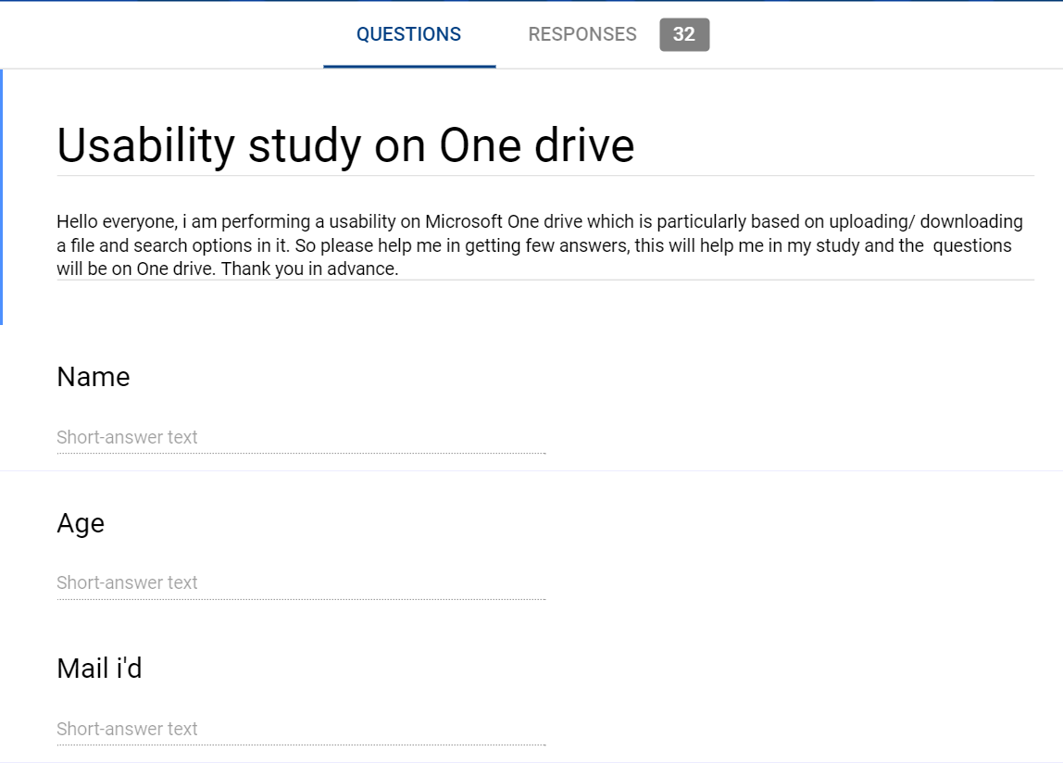

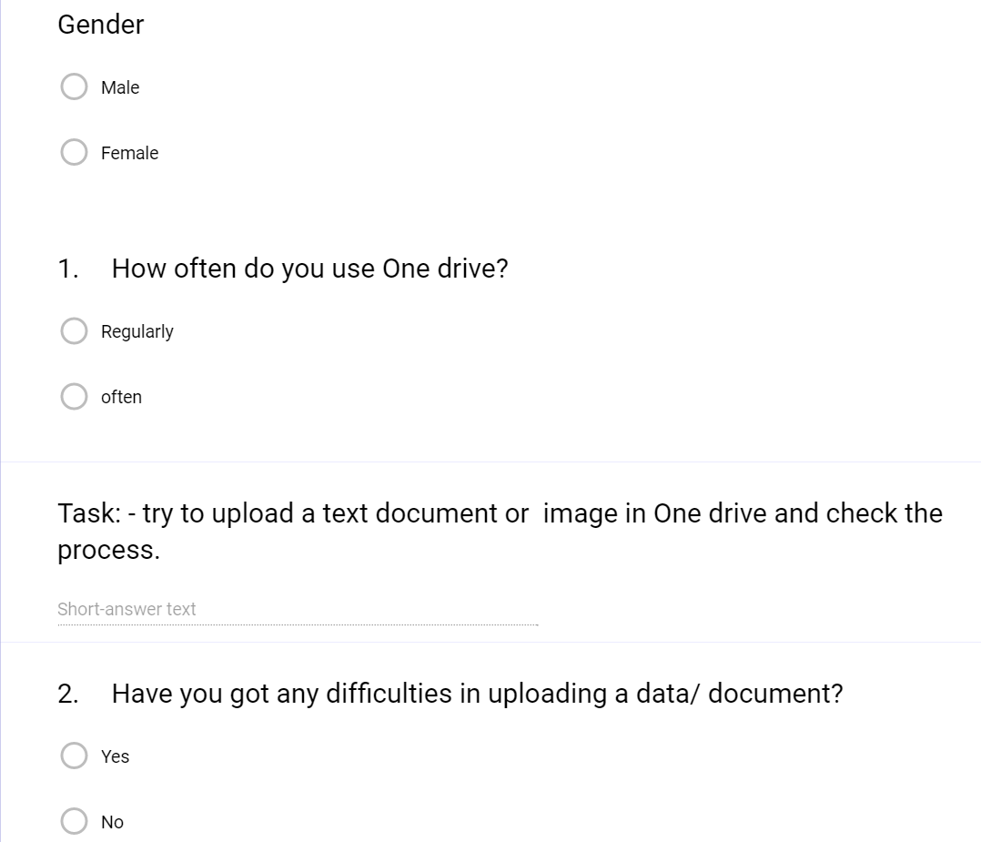

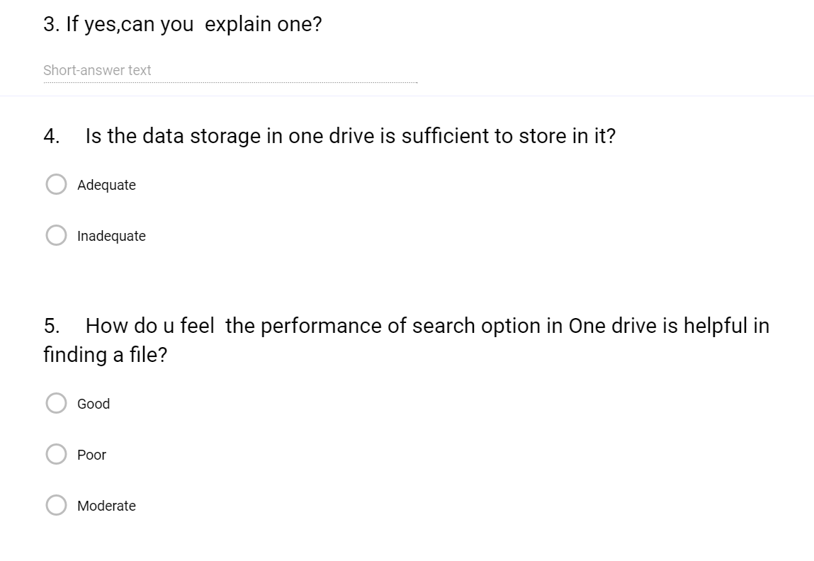

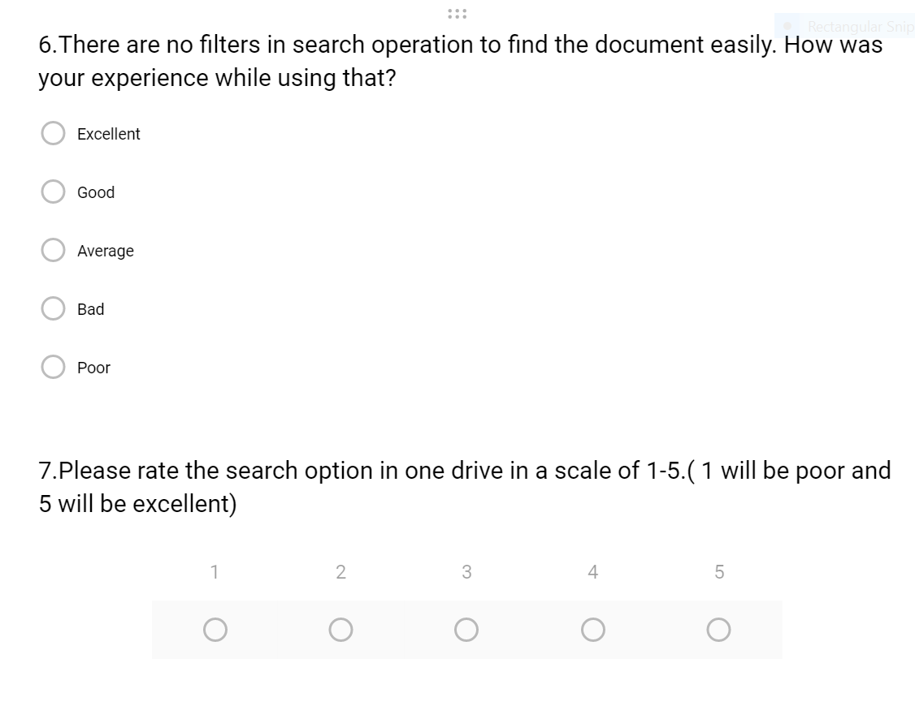

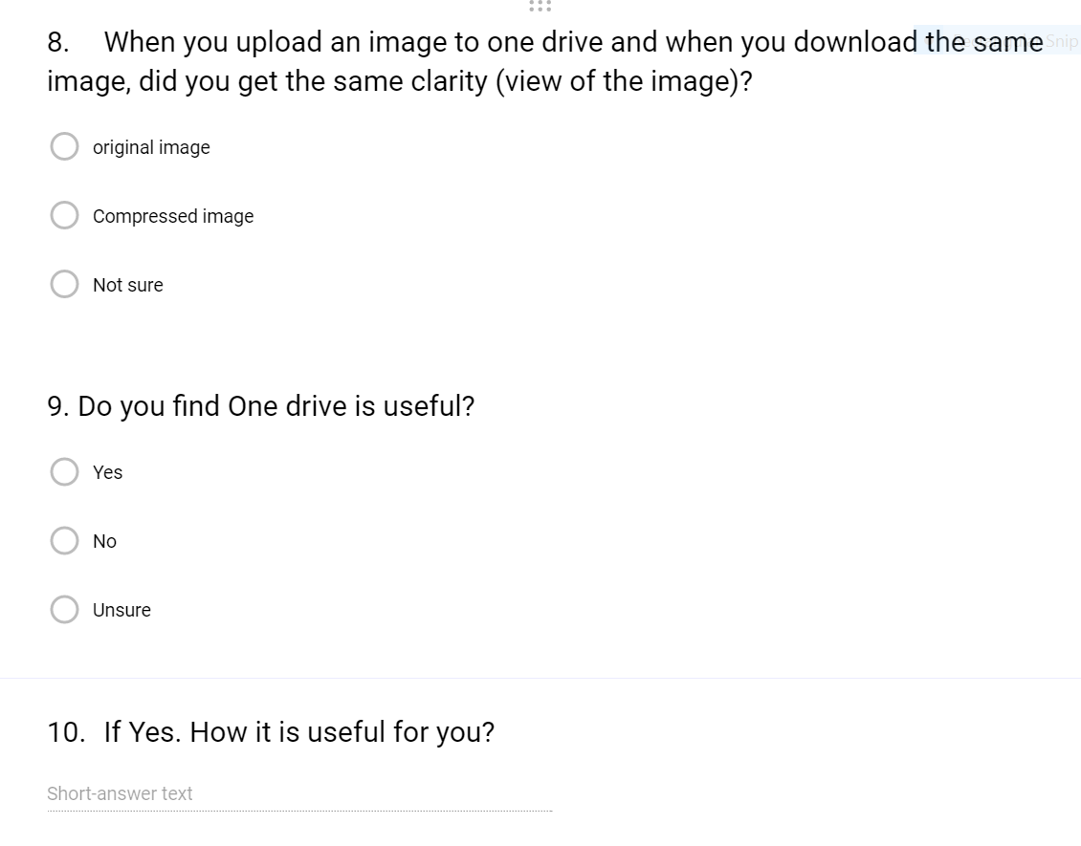

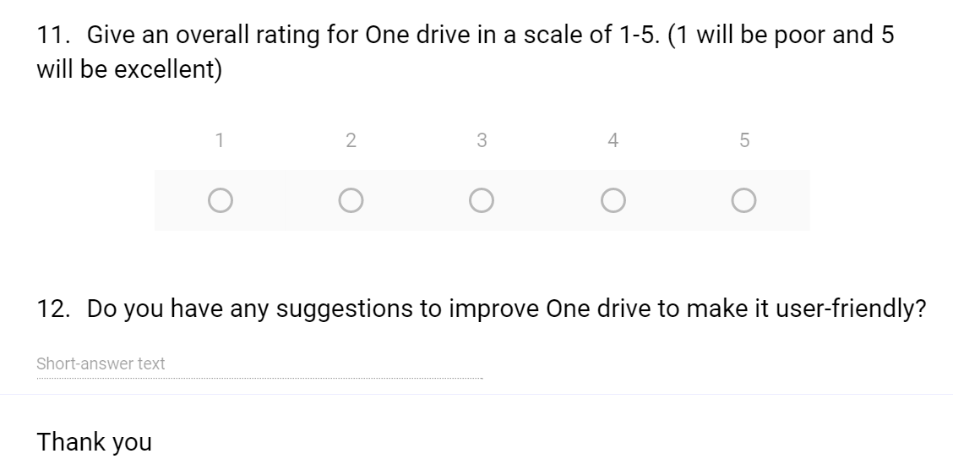

Analysis of Online survey: -

For the analysis process I have used two methods to collect the data 1. Vignette Scenario 2. Data matrix. Here a vignette scenario is used to collect the data from the participants and to summarize them to show the content easily and data matrix is used to prepare the obtained content in a tabular form, these both methods are used from the book “Hackos and Radish”.

Vignette Scenario: -

This method summarizes the total content that I have obtained from the google form and from that information we have like One Drive is used by the most participants regularly and also some of them are often and also most of them answered like the when an image is uploaded to One drive, they get original image and equally answered that they get compressed images as well. Overall rating for the One Drive has rated as good.

Results of Online Survey: - (Data matrix)

From the survey I have got the results for all the questions and also some suggestions from the 32 participants for the improvement of One Drive and to make that user- friendly. Also a individual response is posted on the appendix Section-B. Here the total summary of the results is shown below,

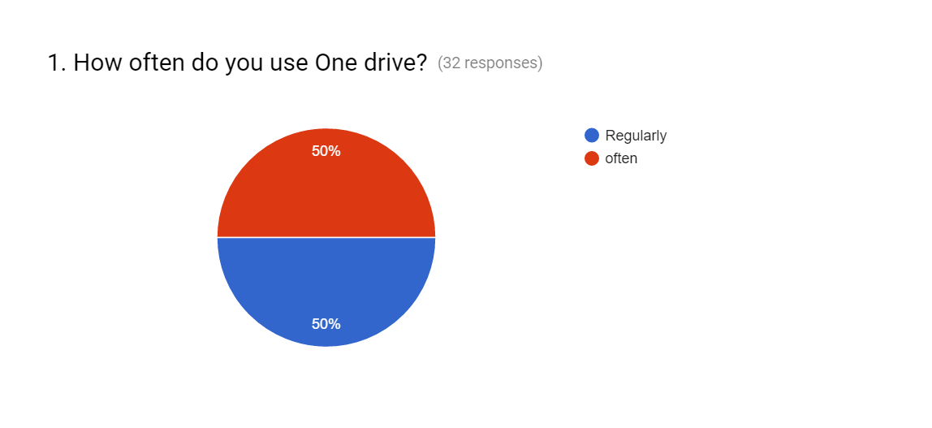

From this Pie-chat we can observe that the total number of participants are 32 and use of One Drive is equal, 16 have used One Drive regularly and 16 of them used it very often. So it is clear that almost all the participants are using One Drive for their daily uses.

FFF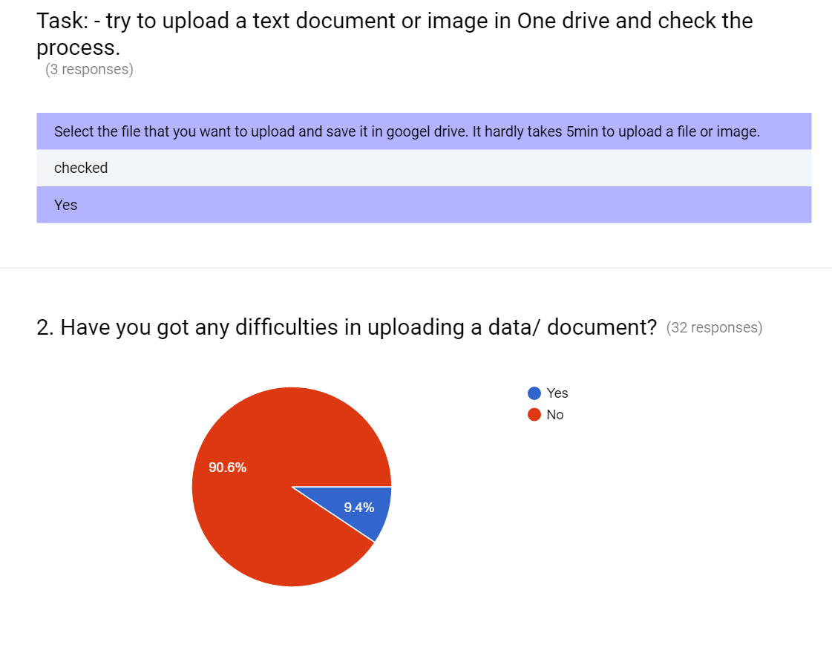

For all the participants, I have made a task in this test. They should try to upload a document and check whether they have got any issues regarding that. The result shows that 90.6% haven’t got any difficulties and 9.4% got issues like consumption of the data is too much and also it takes a lot of time in the uploading process. They also plotted some valuable suggestions to improve this.

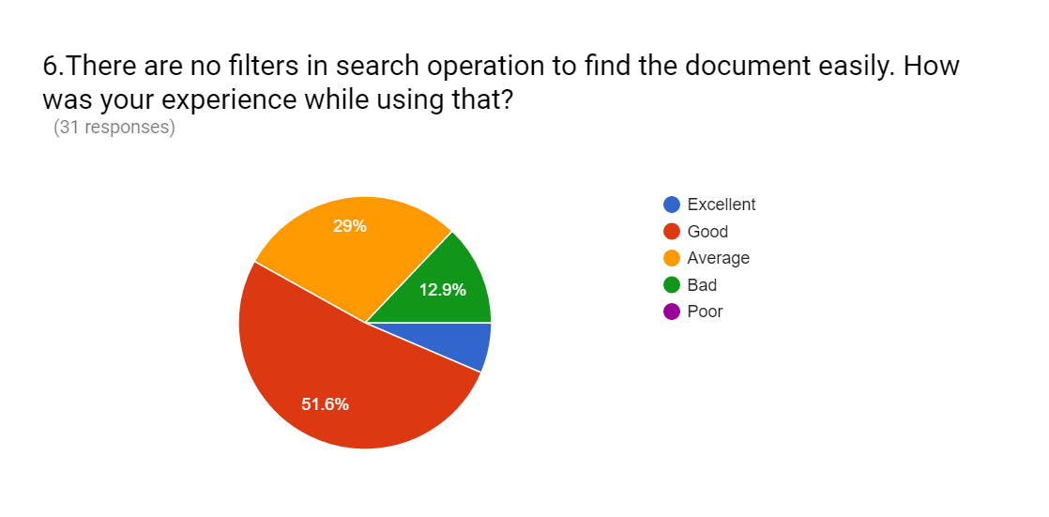

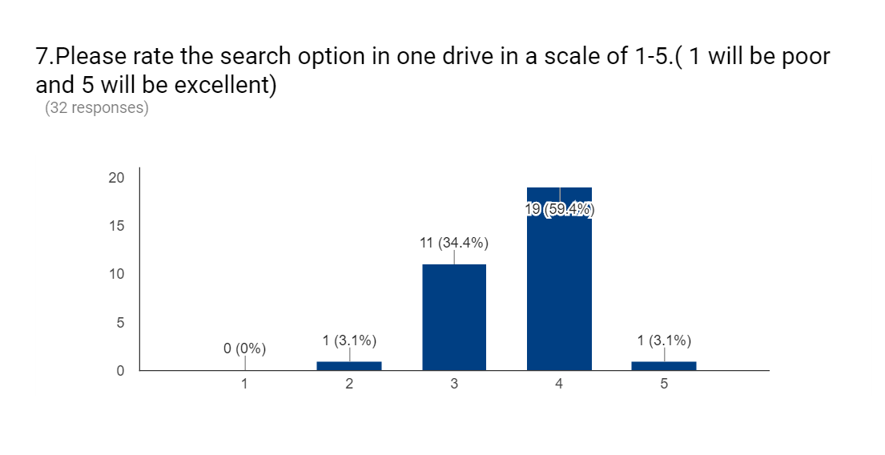

The results show that without the filters in search operation most of the participants are satisfied with that and 29% of them are adjusted with that and 12.9% of them rated them as poor. In addition to that overall rate to the search operation in the scale is 59.4% rated as good and 34.4% people as moderate and no one has rated them poor, With this results One Drive should a bit better in their search operations.

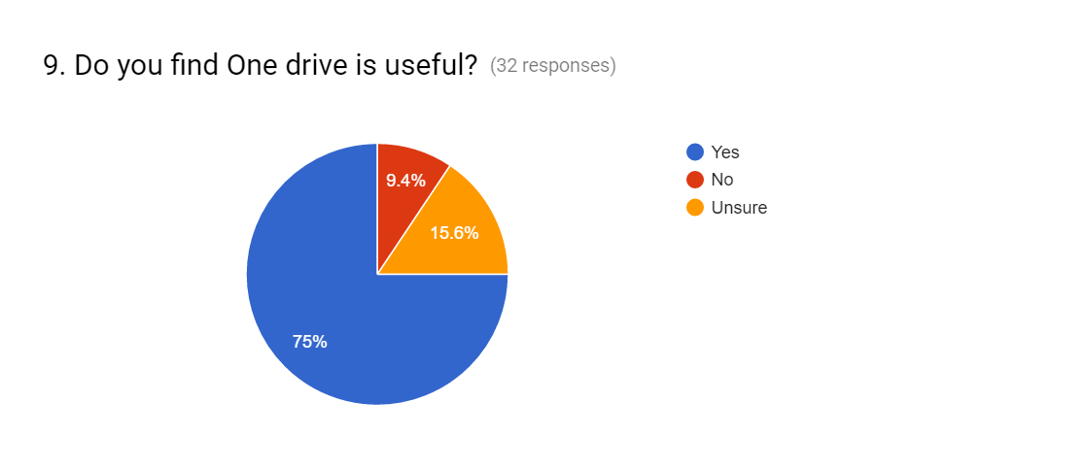

Almost all the participants found that One Drive is most useful for them and also posted their answers, how useful is One Drive to them. Some of their answers are they access the data remotely, they can store their personal data and can easily access that for their future prospects, by storing their data in One Drive they save the storage space on their devices, an individual posted like data which is uploaded in the One drive can be accessed anywhere via cloud storage where he finds internet.

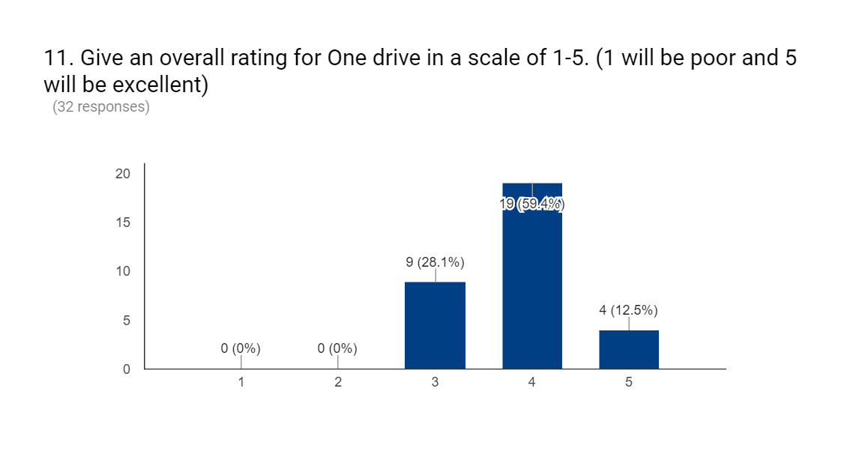

Overall rating for One Drive is rated in mixed results with both good and moderate options above half of the participants i.e., 59.4% have rated One Drive as good at it performance and 28.1% of them as moderate and 12.5% of them rated the One drive as excellent at their performance. From these results we can observe and study that One drive serves all the participants and helps them too.

Conclusion: -

One Drive has got a lot of suggestions, negative suggestion is “it’s always annoying to upload large files as it takes more time it would be better that the uploading of the large files is faster, and the search criteria in the drive is good but there are some issues which I have faced while searching for some files with short names” and positive feedback is “it can store the personal data and to store important information so that we can access anywhere”.

Finally, my study concludes that by improving the search operation module and some more modifications can make a One Drive more accessible to a user.

References: -

1. User and task analysis for interface design by Hackos and Redish.
2. https://frostburg.blackboard.com/bbcswebdav/pid-800145-dt-content-rid-3042404_1/courses/2163_3218_COMB/Usability%20Testing%20and%20Design%20unpublished%20example%20document.pdf
3. <https://en.wikipedia.org/wiki/Microsoft>
4. <https://www.google.com/webhp?sourceid=chrome-instant&ion=1&espv=2&ie=UTF-8#q=one%20drive%20wiki>

Appendix: -

Section A

Two individual participant’s response sheet is attached,

1-1

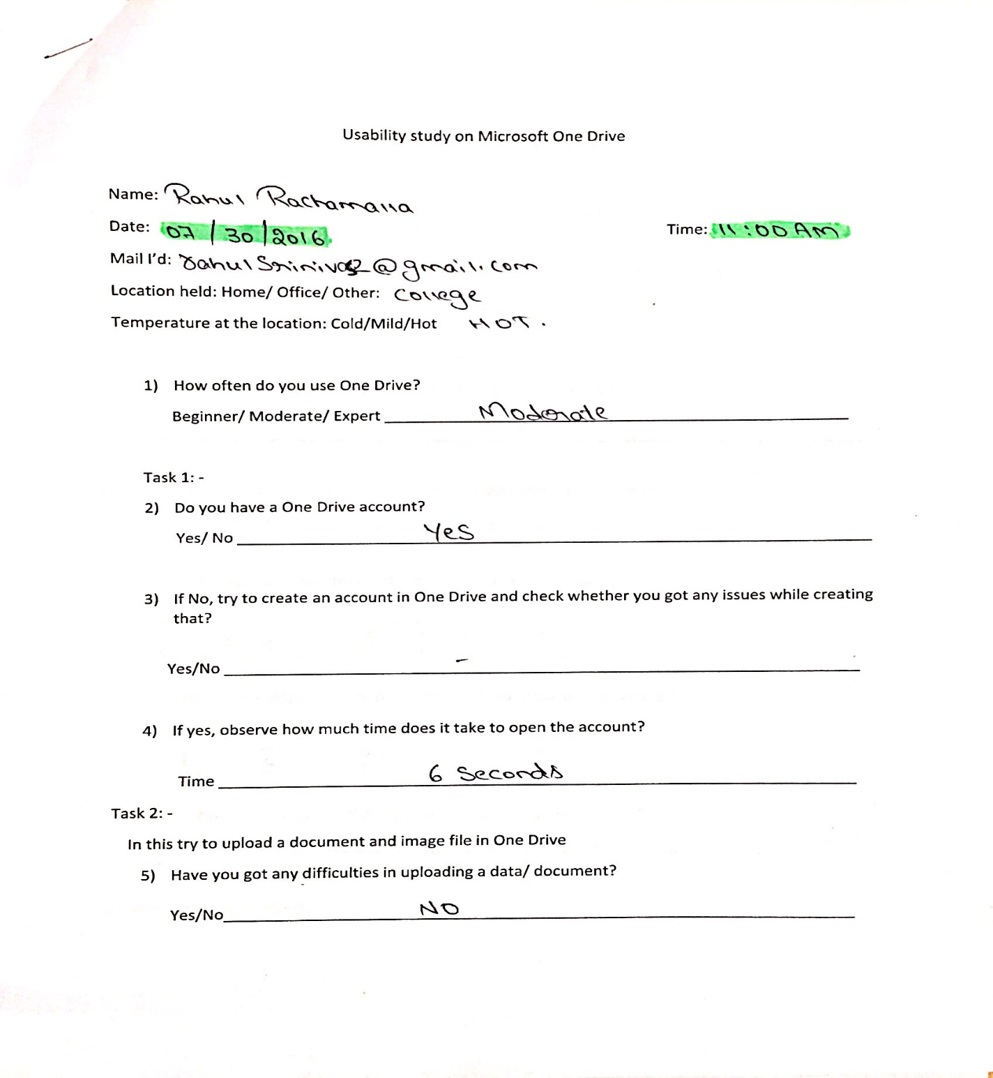

1-2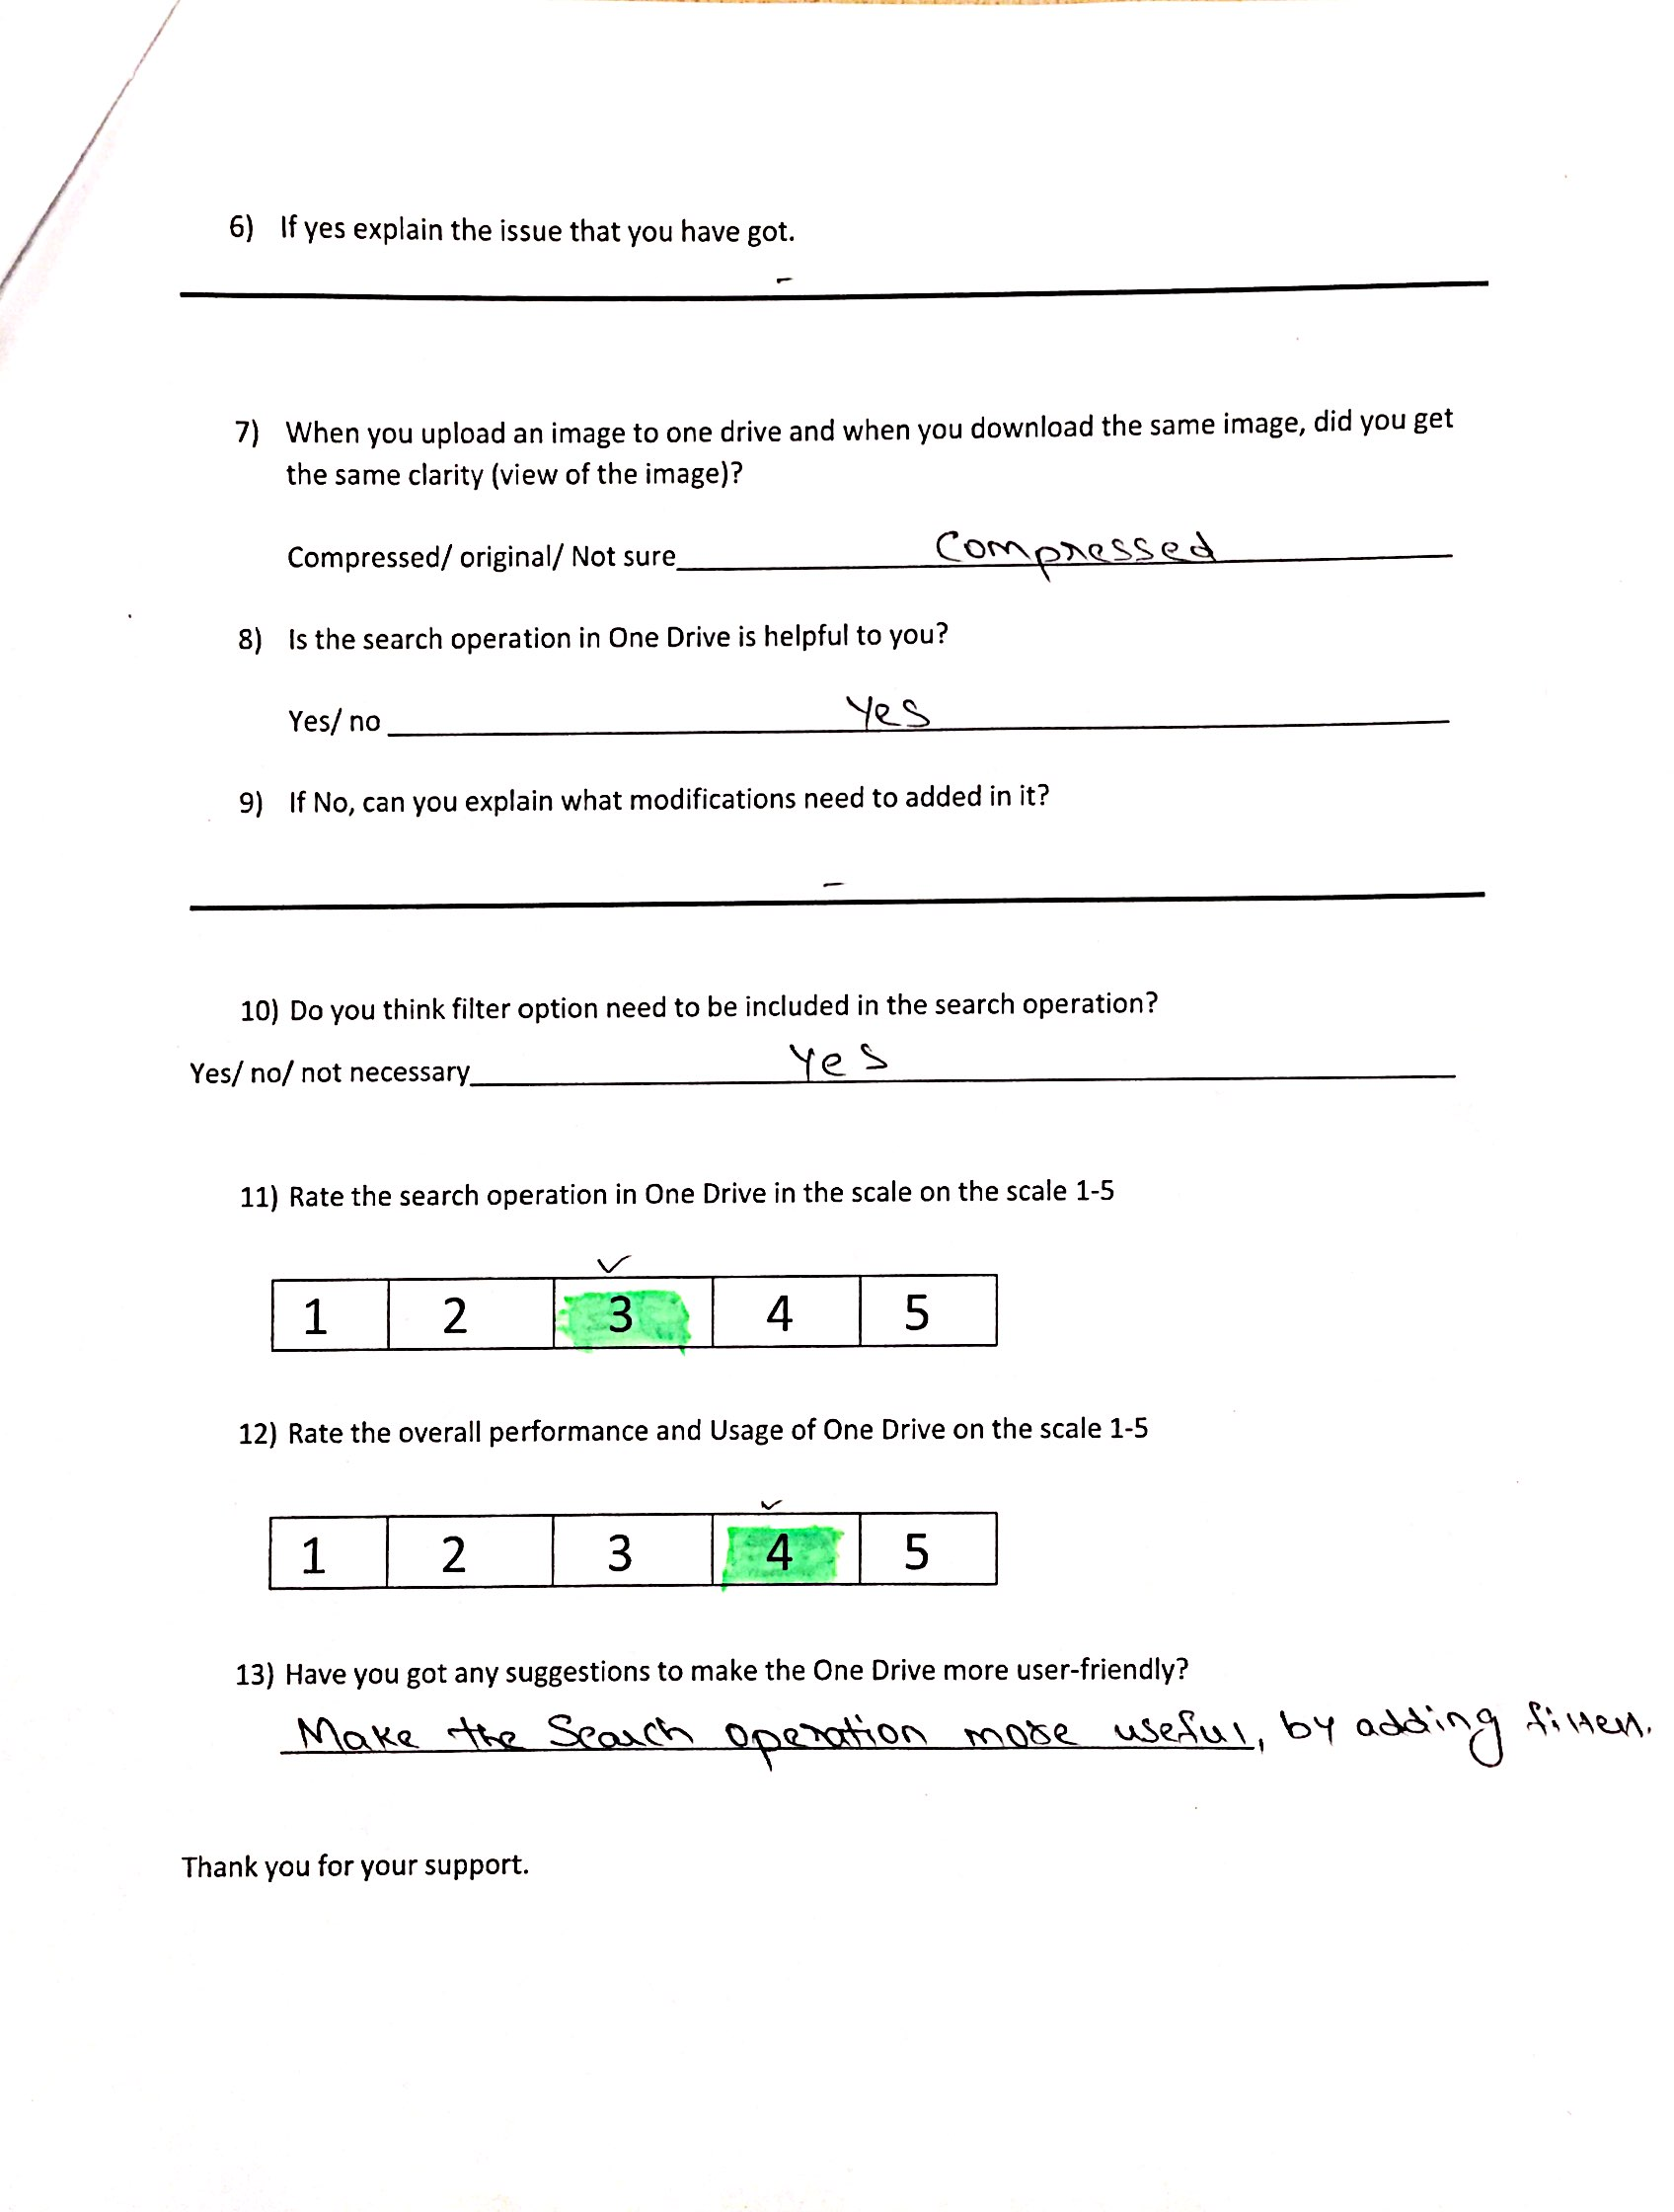

2-1

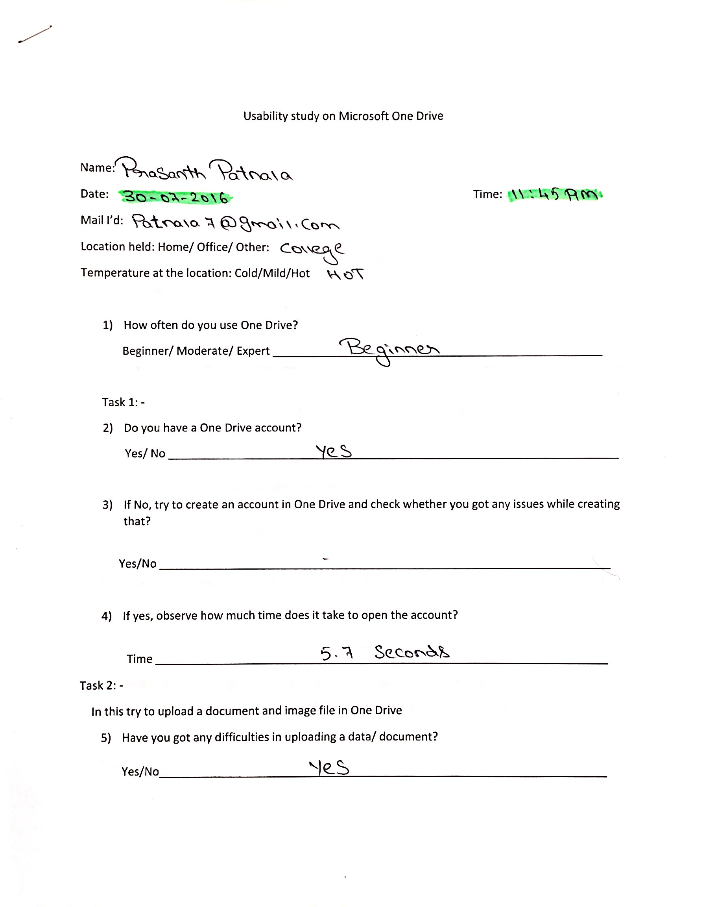

2-2

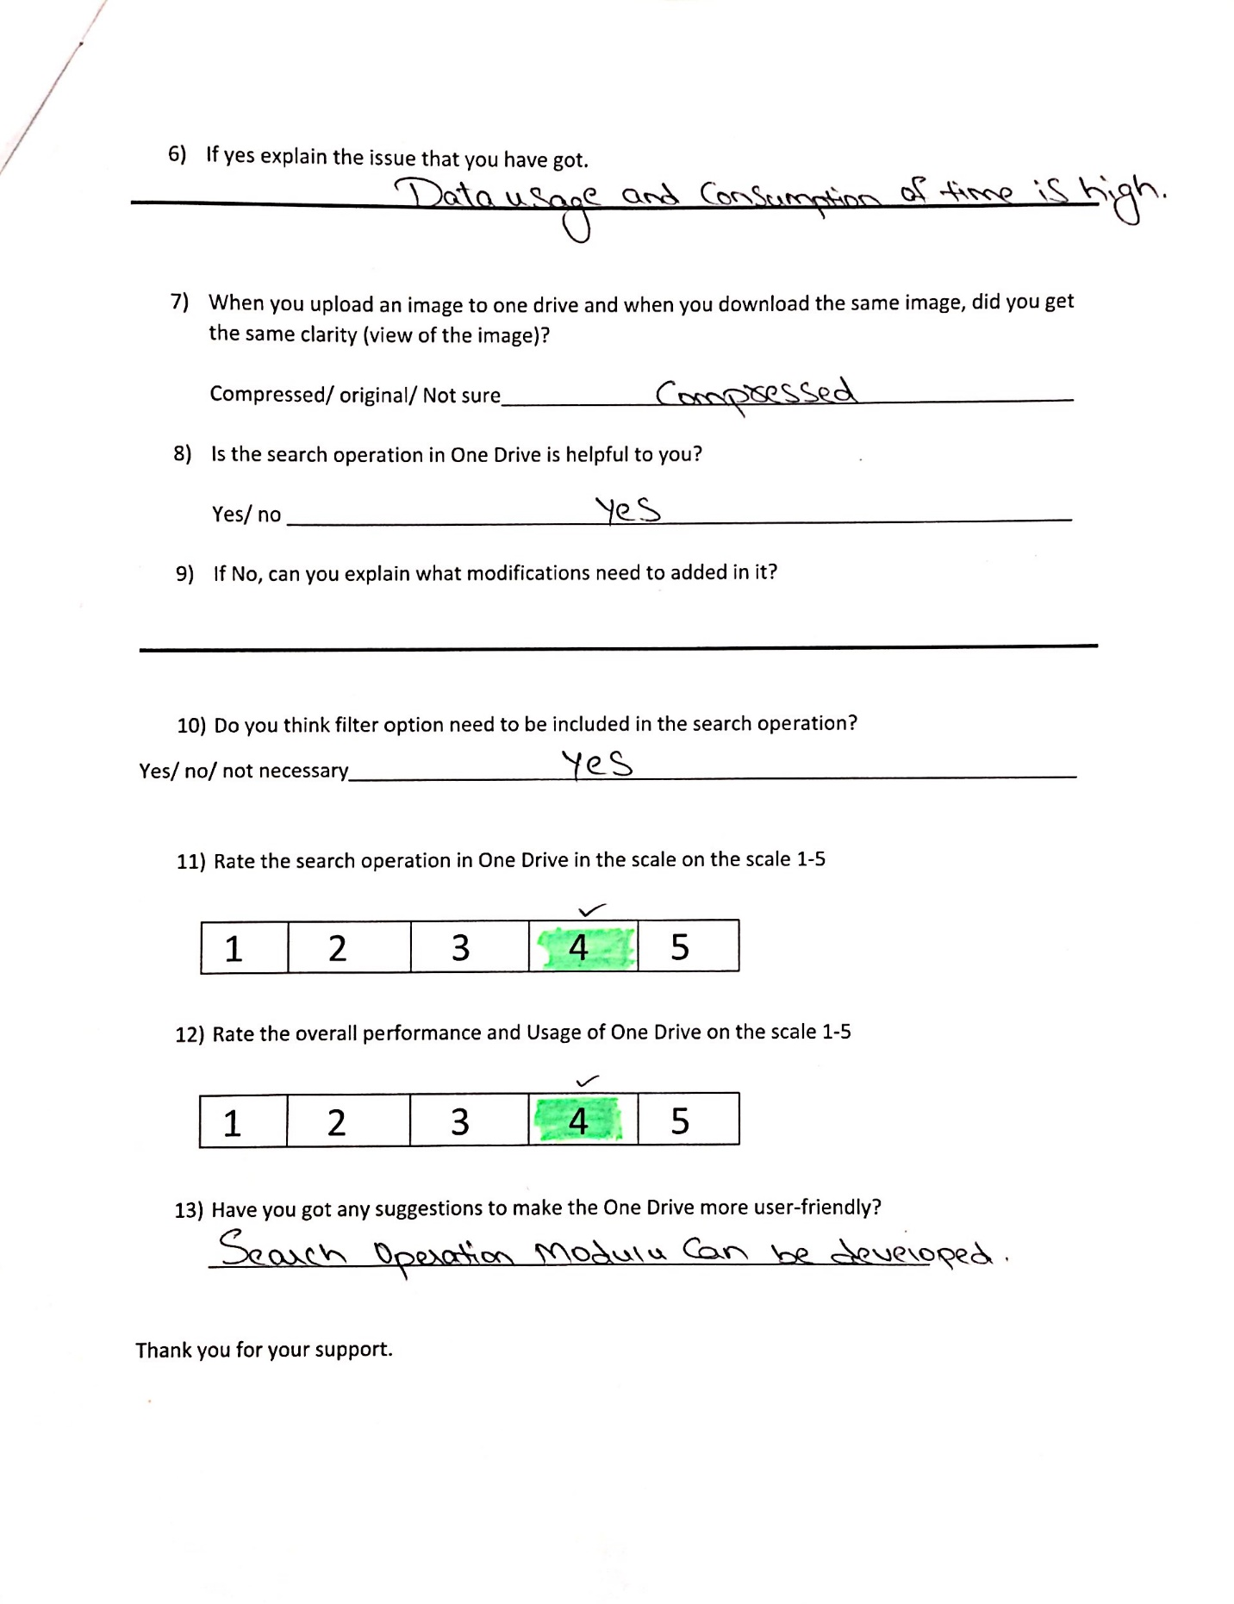

Section B

An individual participant survey report is,

